 |  | TERMO DE ACEITE TÉCNICO
Solicitante: VIVO- Projeto Escolas Rurais
NOC/Operador: Rogerio Momi Frias |  |  | Cliente: VIVO
Empresa  EMC Brasil | VSAT-ID  VIVO-PER- |  | Link kbps  256/128 | Plataforma  VSAT
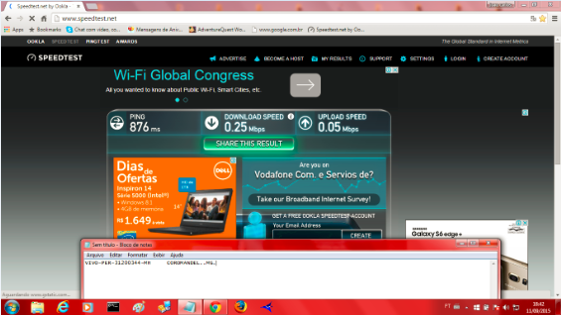

Satellite (DVB) RX Configuration
--------------------------------
Auto start : Enabled
Max MODCOD : 23 16APSK-9/10 (SNR threshold: 23.5 dB)
RX watchdog : 15 minute

Idx Pri SymbRate[Msps] Freq[GHz] Mode PopId Enable
* 0 0 9.320000 12.055825 DVB-S2 4 Yes

Satellite (DVB) Receiver Status
--------------------------------
Rx State : On
DVB State : Forward link up
Network : 1326, GlobalIP@Telstar-14R
Frequency : 12.055689 GHz
Symbol Rate : 9.320031 Msps
S2 ModCod
- receiving : 1 QPSK-1/4
- current max : 23 16APSK-9/10
Pilot : On
Frame length : Short
DVB S2 Mode : ACM
Roll off : 0.25
SNR : 15.2 dB
Input Power : -32 dBm

Satellite (DVB) TX Configuration
--------------------------------
Auto start : Enabled
IDU Output Power : -30 dBm
IDU Max Output Power: 0.0 dBm
ODU Output Power : 33.7 dBm
EIRP : 47.0 dBW
Default CW Frequency: 0.000000 GHz
ATM mode : VC-Mux
Header Compression : None

Satellite (DVB) Transmitter Status
--------------------------------
State : On (TDMA)
IDU Output Power : -20.1 dBm
ODU Output Power : 34.9 dBm
EIRP : 48.2 dBW
Es/No : 14.0 dB
Header Compression : Disabled
Timing correction : -197 us (260634 us)
Frequency correction: -120 Hz

Pinging 10.29.1.145 with 32 bytes of data:

Reply from 10.29.1.145: bytes=32 time=1709ms TTL=61
Reply from 10.29.1.145: bytes=32 time=552ms TTL=61
Reply from 10.29.1.145: bytes=32 time=653ms TTL=61
Reply from 10.29.1.145: bytes=32 time=565ms TTL=61

Ping statistics for 10.29.1.145:
Packets: Sent = 4, Received = 4, Lost = 0 (0% loss
Approximate round trip times in milli-seconds:
Minimum = 552ms, Maximum = 1709ms, Average = 869ms

c:\>ping 10.53.0.126

Pinging 10.53.0.126 with 32 bytes of data:

Reply from 10.53.0.126: bytes=32 time=1701ms TTL=61
Reply from 10.53.0.126: bytes=32 time=556ms TTL=61
Reply from 10.53.0.126: bytes=32 time=650ms TTL=61
Reply from 10.53.0.126: bytes=32 time=572ms TTL=61

Ping statistics for 10.53.0.126:
Packets: Sent = 4, Received = 4, Lost = 0 (0% loss
Approximate round trip times in milli-seconds:
Minimum = 556ms, Maximum = 1701ms, Average = 869ms

ping 8.8.8.8
64 bytes from 8.8.8.8: time=1990 ms
64 bytes from 8.8.8.8: time=780 ms
64 bytes from 8.8.8.8: time=690 ms
64 bytes from 8.8.8.8: time=750 ms
64 bytes from 8.8.8.8: time=720 ms

--- 8.8.8.8 ping statistics ---
5 packets transmitted, 5 received, 0.00 percent packet loss
rtt min/avg/max = 690/980/1990 ms

